IS YOUR CHILD SAFE ON THE INTERNET?
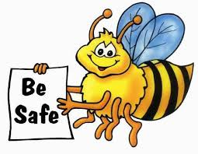
ARLES PARENTS ASSOCIATION along with
THE NATIONAL PARENTS COUNCIL PRESENT AN INTERNET SAFETY SESSION FOR PARENTS
in Arles N.S.
on
Thursday 9th March @ 8PM

All are welcome to attend
No admission fee

