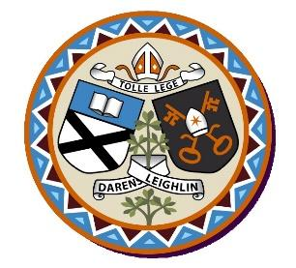
Arles National School
Annual Admission Notice
in respect of admissions to the 2023/2024 school year
Admission Policy and Application Form
A copy of the school’s Admission Policy and the Application Form for Admission for the 2023– 2024 School Year is available as follows: –
To download at: www.arlesnationalschool.ie
On request: By emailing principal@arlesnationalschool.ie or writing to Arles NS, Ballickmoyler, Co. Laois R93HY62

Part 1 - Admissions to the 2023/2024 school year

Application and Decision Dates for admission to 2023/2024 School Year
The following are the dates applicable for admission to Junior Infants
The school will commence accepting applications for admission on | 5th January 2023
The school shall cease accepting applications for admission on | 26th January 2023
The date by which applicants will be notified of the decision on their application is | 16th February 2023
The period within which applicants must confirm acceptance of an offer of admission is | 2nd March 2023

Note:
Failure to accept an offer within the prescribed period above may result in the offer being withdrawn
The school will consider and issue decisions on late applications in accordance with the school’s Admission Policy.
Number of Places being made Available in 2023-2024 School Year

The number of places being made available in Junior Infants | 20

