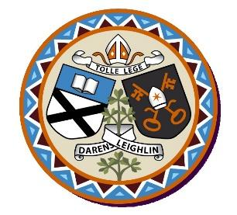
Arles National School
Annual Admission Notice
in respect of admissions to the 2024/2025 school year
Admission Policy and Application Form
A copy of the school’s Admission Policy and the Application Form for Admission for the 2024 – 2025 School Year is available as follows:
To download at: www.arlesnationalschool.ie
On request: By emailing principal@arlesnationalschool.ie or writing to Arles NS, Ballickmoyler, Co. Laois R93Hy62

Part 1 - Admissions to the 2024/2025 school year

Application and Decision Dates for admission to 2024/2025 School Year
The following are the dates applicable for admission to Junior Infants
The school will commence accepting applications for admission on | 8th January 2024
The school shall cease accepting applications for admission on | 29th January 2024
The date by which applicants will be notified of the decision on their application is | 19th Feb 2024
The period within which applicants must confirm acceptance of an offer of admission is | 4th March 2024

Note:
Failure to accept an offer within the prescribed period above may result in the offer being withdrawn
The school will consider and issue decisions on late applications in accordance with the school’s Admission Policy.
Number of Places being made Available in 2024-2025 School Year

The number of places being made available in Junior Infants | 20

